Q1. Explain Abstraction in java programming?

Ans: Give Essential Details to the user in summarized Form

Abstraction in java refers to hiding implementation details of a code and exposed only the necessary information to the user.

There are two ways to achieve abstraction in java

1. Using abstract class (abstraction we can not find 100%)
2. Using Interface (100% abstraction we can find)

Abstract class:

1. Abstract class is the collection of abstract method or non abstract method
2. We cannot create an instance / object of Abstract class
3. Abstract class can have a constructor
4. Abstract class can inherit another abstract or non abstract class
5. An abstract class can implement any interfaces
6. The abstract keywords in an non-access modifier, used for classes and methods

**Abstract method**: can only be used in an abstract class, and it does not have a body /definition. The definition / body /implementation provided by its child classes.

**Abstract class:** Ia a restricted class that cannot be used to create objects. It must be inherited from another class

We cannot create an object of abstract class but it can store reference of its child class.

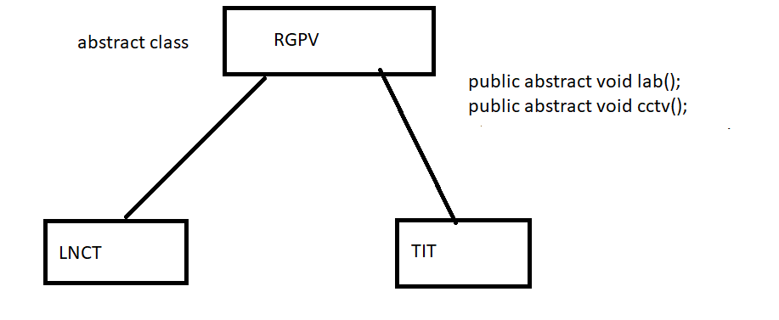

Apart from abstract class method a child class can have its own method

abstract class RGPV{

public abstract void lab();

public abstract void cctv();

//abstract

public void examCopyCheck(){

System.out.println("This Is RGPV non abstract method");

}

public RGPV(){

System.out.println("This is RGPV CONStrUCTOR");

}

}

class College extends RGPV{

public void cctv(){

System.out.println("This is CCTV Method Rule by RGPV");

}

public void lab(){

System.out.println("This is lab Method Rule by RGPV");

}

public void staff(){

System.out.println("This is College class Staff Method");

}

public College(){

System.out.println("This is College CONStrUCTOR");

}

public static void main(String args[]){

//RGPV obj=new RGPV();//C.E.

RGPV obj=new College();

obj.cctv();

obj.lab();

obj.examCopyCheck();

//obj.staff();

College c=new College();

c.cctv();

c.lab();

c.examCopyCheck();

c.staff();

}

}